Daljeet Singh
3169763
Assignment 2

PART- I
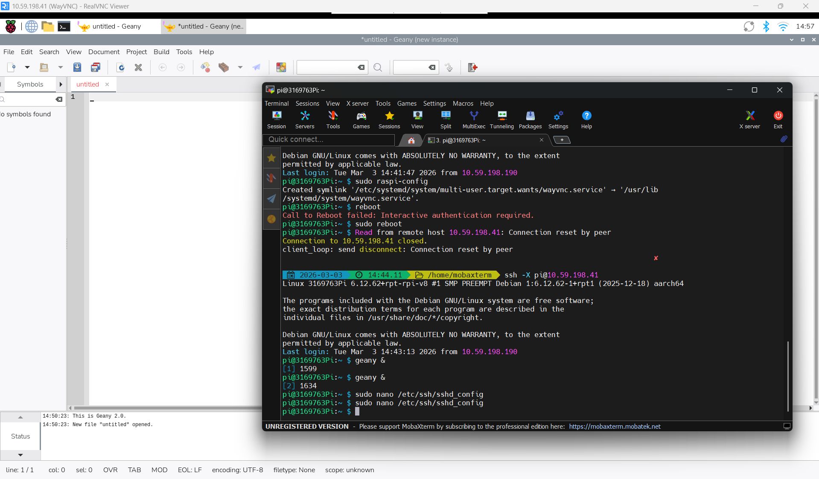

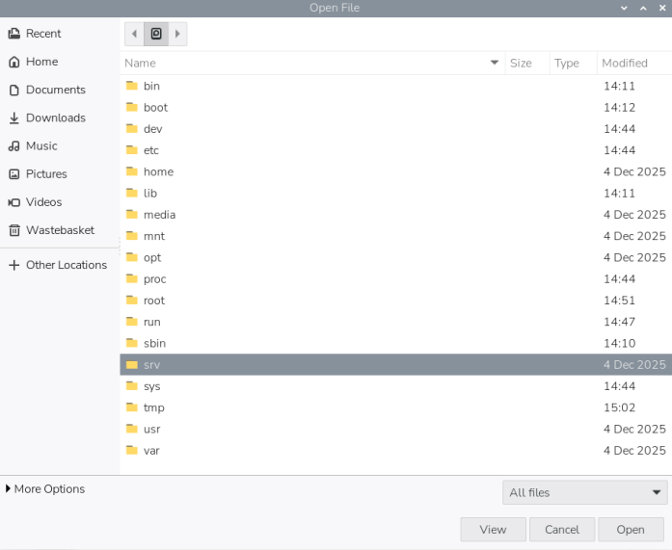
PART – II
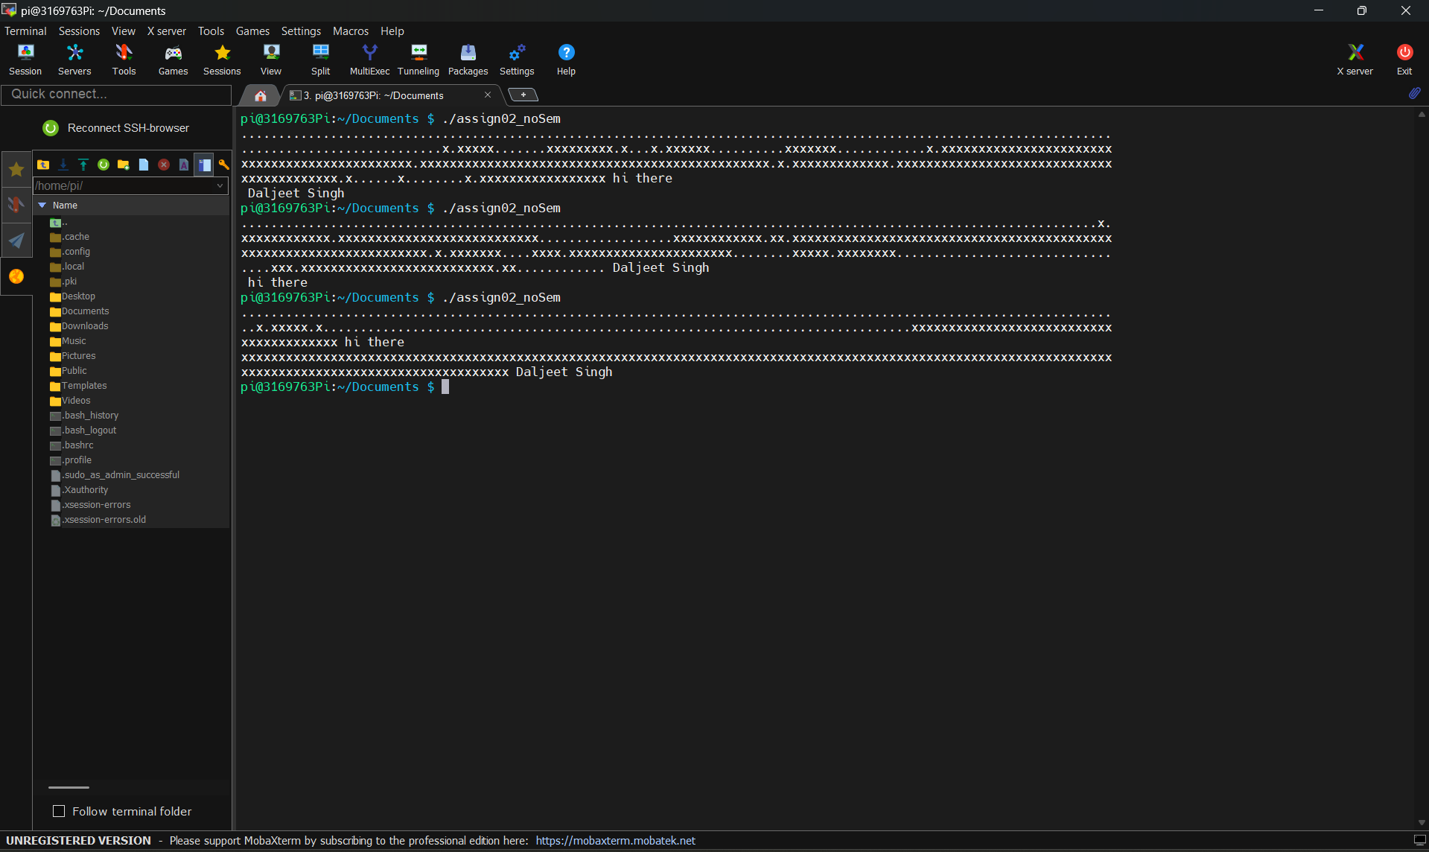

In this program, both threads run at the same time without any coordination. The CPU switches between these codes randomly because there is no synchronization. That’s why sometimes “hi there” prints first and sometimes “Daljeet Singh”.

PART - III
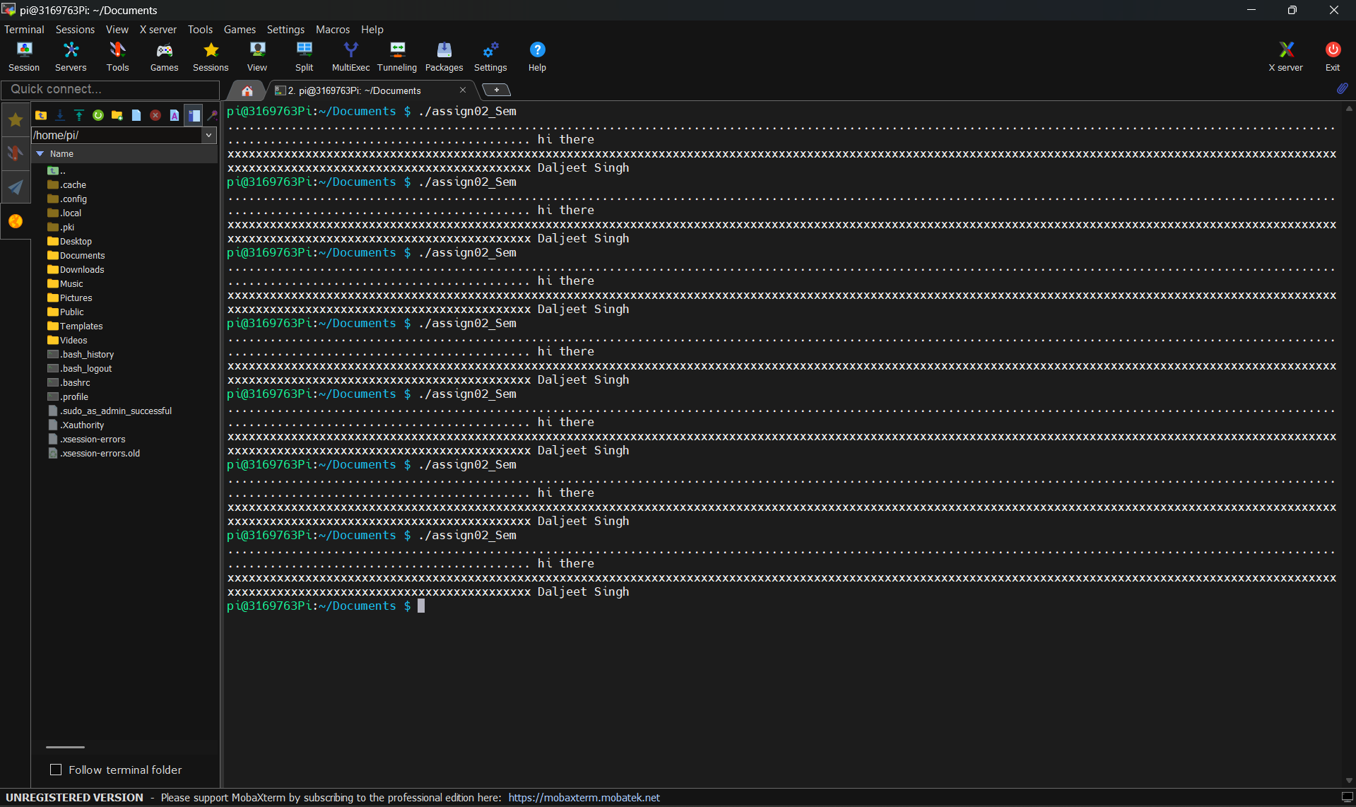

In Part III, the semaphore is used to synchronize the two threads and control their execution order. It makes the code to print "hi there" line first before the "Daljeet Singh" line by blocking the second thread until the first thread finishes. This provide proper output every time the program runs.

PART - IV
